FEAR – POwered Armor Combat

Introduction

Getting Started

Fortunately the Powered Armor combat is pretty straightforward and easy to set up. It only has one specialized node, AINodeArmored, that you have you can use to create a point for the Powered Armor to shoot & attack from. It works in the same general way that the Ambush nodes work for the Assassins and Shadow Creatures.

Load up the “Powered_Armor” world and have a look at the way the world is set up. The floor and ceiling dimensions are just about big enough for the Powered Armor so that it has room to maneuver as well as a slight buffer space between it and the ceiling. There are a few spots where the NavMesh seems to narrow in places – these are AINavMeshLinkDiveThru links, which are specialized AINavMeshLinks that make the Powered Armor play special animations and smash through physics objects, sending them flying around. Of course, using an AINavMeshLinkDiveThru alone won’t make it work, so you need to set the SmartObject of this NavMeshLink to something appropriate for the PoweredArmor to use (like PowerArmorSmashThrough for example.)

Once you’ve done that, you’ll need to set up the prefabs you want the PoweredArmor to smash through so that they go flying when the NavMeshLink is triggered. Take a look at the prefab Crates_PowerArmor_Smash in the Prefabs/XP_Interactive folder. Open it in its separate world window and examine how it works. You’ll want to set up your own custom “smash through” prefabs in a very similar way.
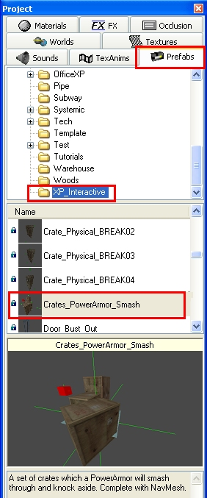

AiNodeArmored

This is the node that the Powered Armor and Powered ArmorXP use to attack from. These nodes aren’t even really necessary if you set your CAI’s ConfigureAI->SeekEnemy to True. However if you’ve designed the area such that you don’t want the PoweredArmor to seek the player out immediately, then you will need to use the AINodeArmored node in conjunction with the other nodes you might use to set up the combat (AINodeGoto, etc.) This also applies to other enemy AI – if you don’t set them to SeekEnemy = True, they won’t chase the player until he comes into site and they have valid nodes to move to.

Style Considerations

When using a PoweredArmor or PoweredArmorXP, you’ll almost always want to have it smashing through walls, knocking over dumpsters, and generally causing a lot of mayhem. It looks really convincing and menacing and it’s a nice immersive touch to kind of sell the fact that the objects around you in the world have physical properties that pale in comparison to that of the massive hulking fifteen foot mech that’s tossing them around like they’re toys. It’s a wasted opportunity to not throw at least a few of these instances into your Powered Armor battle.

Conclusion

The Powered Armor is a powerful boss type enemy and should be used sparingly. It has an extremely high hit point value, so make sure you’re giving the player enough ammo and health when leading into a Powered Armor fight, and always make sure to have the PoweredArmor smashing through things!!

